Ideas

Overview
Our economy will be innovative by embracing technological change and collaborating across sectors to support globally leading, cutting edge R&D and enable the broader diffusion and adoption of innovation across our business base.
      - Our strategy for Ideas focusses on the following themes:
- Frontier sector innovation: to build on our internationally significant innovation capabilities within our established frontier sectors to stay ahead in the global market;
- Cross-sector collaboration: to exploit the synergies in innovation across our frontier sectors, creating new R&D partnerships and generating new routeways to excellence which will expand and diversify our sector strengths, business base and global markets;
- Innovation diffusion and adoption: to increase innovation capability across the business base and embed innovative cultures, technologies and processes that will support productivity uplifts, increased competitiveness and diversification.
      - We are home to leading global businesses at the cutting edge of innovation in Advanced Manufacturing, supported by a supply chain cluster of high-tech small and medium-size enterprises (SMEs). There are longstanding and well-known strengths in Aerospace, Automotive, and Energy industries as well as specialist Chemical and Food industries along with exciting emerging strengths in sectors including Digital, Applied Healthcare, Clean Tech and Deep Tech spin-outs from our universities.
      - We are home to an extensive range of innovation assets, concentrated primarily along the West to East corridor (M55-M6-M65) and around the Lancaster University and UCLan Campuses. A distinct strength for our county is we have four universities collaborating on SME Innovation and two with strong research pedigrees. Our Higher Education Institutes have diverse research strengths - spanning Allied Health Professions, Chemistry, Computer Science, Earth Systems and Environmental Sciences, Management Science, Engineering, Mathematical Sciences and Physics – and work closely with national centres of research excellence and knowledge transfer partnerships and locally at a translational level through demonstrators such as AMRC(NW).
      - Aligned to our sector strengths and priorities, our existing innovation capabilities and our desire to forge collaboration across our frontier sectors, we are building our innovation ecosystem strategy around four foundations:
- Advanced Manufacturing and Mobility: taking forward our key strengths in manufacturing with specialisms across several sub-sectors, most notably in aerospace and automotive and associated engineering assets and emergent technology eg novel battery tech
- Clean Technology Commercialisation: expanding our well-established nuclear supply chain opportunities around offshore wind and ambitious zero carbon targets and leveraging our research to develop and commercialise low carbon and sustainable technology product SMEs supporting all sectors.
- Cyber Security, Space and DARQ Technologies: taking advantage of key emerging market opportunities, building on Lancaster University and UCLan’s Cyber Security strengths, Lancashire’s position as a key partner in the new North West Space Hub and our digital economy and Deep Tech strengths for example in advanced sensors and Quantum.
- Healthy Productive Communities: building on our single largest employment sector, Health, and emerging Life Science asset base including Lancaster University’s Health Innovation Campus, health systems and data technology and UCLan’s programmes with a focus on Medtech and emerging diagnostic technologies such as in pathology.

Frontier sector innovation

Rationale & objectives
      - Lancashire has recognised sectoral strengths and differentiators. These strengths need to be developed and worked harder in order to ‘stay ahead’ of new and existing competitors internationally. Industry 4.0 brings unparalleled technological advances - Artificial Intelligence, Automation, Robotics, Big Data, Supercomputing, Advanced Materials, Nanotech, Biotech and Satellite applications - which are increasingly shaping our lives and industries.
      - These technological drivers of change have been magnified and accelerated by the impact of COVID-19, most notably our shift towards an increasingly digital economy and society. The pandemic has also brought health and environmental sustainability imperatives into even sharper focus.
      - Lancashire’s frontier sectors need to both drive and respond to these emerging technologies and market disruption and also work with key movers like BAE Systems to think about what comes after Industry 4.0. Our capabilities can be marshalled not only to increase the competitiveness and productivity of our sectors and businesses but also to generate solutions that address the grand challenges facing our society and meet the needs of people, place and planet.
      - It will be vital to start, grow and scale up more truly Innovation Driven Enterprises (IDEs) with international and technology driven mindsets to nurture the future economic base of the county and reduce reliance on some traditional sectors.
Figure 6-1: Frontier sector innovation objectives
Priority area | Objective
Priority 1: Drive innovation and boost competitiveness in context of Industry 4.0 | Maintain Lancashire’s distinctive world-class prominence in priority sectors
 | Increase national and international R&D collaboration and develop strategic partnerships with Centres of Excellence outside of Lancashire
 | Developing supply chain capability and capacity servicing these sectors
Priority 2: Support cutting edge R&D and commercialisation | Capitalise on HE and wider research specialism and facilitate public, private and third sector R&D partnerships.
 | Foster and nurture more innovative spin-off and start-up firms and facilitate routes to commercialisation through greater Investment Readiness and access to Risk Capital to develop IDEs as the future anchor companies of Lancashire.
 | Stimulate research, development and commercialisation of innovative solutions that respond to society’s grand challenges and the needs of people, place and planet.

Assets & opportunities
      - Lancashire is home to a diverse range of innovation capabilities and assets. We are one of the UK’s most competitive areas for advanced manufacturing and engineering with automotive and aerospace manufacturing sub-sectors being key strengths. Our innovation strategy must capitalise on Lancashire having the 4th biggest aerospace cluster in the world and the highest concentration of aerospace companies nationally (c. 13,000 jobs) and being home to leading manufacturing employers such as BAE Systems and Rolls Royce.
      - Alongside a package of nationally significant innovation assets such as the AMRC NW, and regionally significant assets such as the Engineering Innovation Centre (EIC) at UCLan, Lancashire’s manufacturing base is led by aerospace (internationally leading in developing 6th Generation Fighter Aircraft), automotive, and energy sectors, with additional strengths in digital, healthcare, specialist chemical, agri-food and agri-tech sectors. All sectors will be impacted by digitalisation and the need to lead, manage and adopt secure digital solutions sharing best practice in a field in which we have enjoyed strengths and can cross-fertilise growth. Our assets in Cyber-Security and Quantum at Lancaster University will further support the sector as will strengths in engineering and drones through the Engineering Innovation Centre at UCLan.
      - We must also capitalise on our Low Carbon Energy assets, supply chain and research specialisms which include nuclear, wind, marine, hydrogen, and battery technology and importantly support for SMEs in all sectors to develop low carbon and sustainable products and services. Lancashire leads a North West consortium of universities delivering the Eco-I NW project from the internationally significant Lancaster Environment Centre (LEC) which has one of the largest concentrations of environmental researchers in Europe. Climate change requires us to develop new products, production processes, new approaches to resource use, and new methods of land management. Clean Tech is also one of the fastest growing markets in the world providing considerable opportunities that can build on our strengths.
      - We have declared a net zero emissions target by 2030 and are targeting a 57% reduction in CO2 emissions on 1990 levels by 2032. In order to achieve these targets, we need to expand our existing low carbon capabilities providing high-value design and manufacturing skills across sectors not just our renewable energy industry.
Figure 6-8: Advanced Manufacturing Research Centre NW

Advanced Manufacturing Research Centre NW
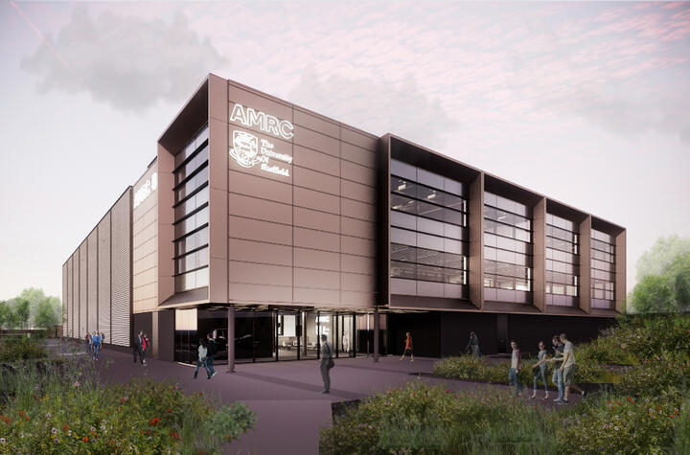
The Advanced Manufacturing Research Centre NW, based on the Salmesbury Enterprise Zone, alongside BAE Systems, is a nationally leading advanced manufacturing centre supporting manufacturers to engage and adopt new technologies, processes and materials to reduce costs and drive efficiencies.

The aim of the centre is to de-risk adoption of technologies that can solve manufacturing problems and improve operations, supporting the SME manufacturing community to access advanced technology that will drive improvements in productivity, performance and quality. Expert support is given in areas including:
- Machining
- Additive Manufacturing (3D Printing) Polymers and metallics
- Design and prototyping
- Virtual reality
- Robotics
- Manufacturing automation
- Discrete event simulation
- Data collection from legacy equipment
- All aspects of digital manufacturing and processing including Medtech
- Digital transformation strategy in a manufacturing environment
Figure 6-3: Clean & Deep Technology Commercialisation
Eco-I NW and DeepINC
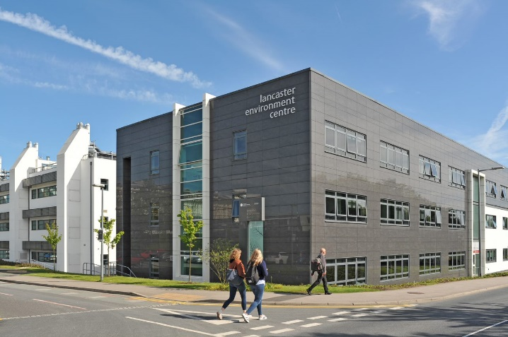
Our future high growth and anchor companies that will support knowledge intensive employment will rely on driving emergent technologies that underpin clean and deep tech. Key will be networking our Innovation Assets supporting clusters of Innovation Driven Enterprises (IDEs) to cross fertilise technology and act as an integrated Accelerator for R&D and high growth tech companies.

This would include world-leading technology development facilities for example those located at Lancaster University, in its Quantum Technology Centre (QTC) and Collaborative Technology Access Platform (cTAP) and in its science departments, with new integrated incubation space and business support, to provide a platform to help locally-based companies to develop research intensive deep technology solutions to their commercially defined problems. It would provide access to integrated space and labs, pioneering expertise, research programmes, collaborative partners and fund managers to accelerate knowledge intensive businesses and retain and return graduate entrepreneurs to Lancashire.

Already we have led in creating a consortium of universities through the Eco-I NW project and a further example of this networked hub approach would be a joint Centre for Advanced Sensor Technology representing a national centre of excellence for research and innovation in environmental sensing, survey and inspection suited to drones and satellites. It will bring together expertise in drone application areas, data acquisition, processing and applications and will accelerate the multidirectional flow of information for improved and more effective decision making and enhanced productivity as we move towards a digitally enabled environment and support the transition to Net-Zero.

Cross sector collaboration

Rationale & objectives
      - We will adopt the principles of smart specialisation. Building on, and extending beyond, the core technologies (e.g. Materials, Automation; Deep Tech applications etc) and specialisms within our frontier sector base, we will take advantage of the technological convergence across related sectors and industries and create new opportunities for innovation and growth.
      - We must continue to ‘recreate’ our economic base through building new sectoral Unique Selling Points (USPs). ‘Standing start’ sectoral development is increasingly difficult to deliver, and so instead, we should focus on the connectedness - in terms of technological crossover and synergies - across our industrial base (and with wider national and global partners) so that we can expand and diversify into new and adjacent sectors and specialisms. We have a diversity of sector strengths and supply chains in Lancashire, with significant untapped potential to combine our capabilities to open up these new opportunities in order to grow and internationalise our economy. Our approach, enabled by strong sector leadership, will require partnership and collaboration across industries and businesses from different sectors.
      - We are also prioritising cross sector innovation in terms of collaboration across our public, private and third sectors and research institutions. This partnership approach is well evidenced through our health and life science agenda, bringing together wide-ranging stakeholders - the NHS, biotech firms, academic researchers and local authority & community health providers. There is a visible and well-documented gap between the North and South in England in terms of health outcomes, and this has widened since the pandemic. Our collaborative, cross-sector approach to innovation in this field is designed to identify innovative and scalable health solutions, contributing to both our economic growth and health and wellbeing objectives
Figure 6-4: Cross sector collaboration objectives
Priority area | Objective
Priority 1: Driving local cross sector collaboration | Build distinctive cross-over driven strategy (where existing core technologies ‘cross-over’ into new sectors) to exploit existing strengths;
 | Enhance cross sector collaboration with local academic institutes and public bodies, combining research strengths with business to extend capability and forge new routes to excellence.
 | Prioritise R&D, innovation, and skills development for emerging sectoral strengths;
Priority 2: Driving national and international cross sector collaboration | Identify synergies between local key sectoral capabilities with complementary external assets and strengths across the wider Northern Powerhouse, UK and internationally.
 | Develop new global supply chain participation and inward investment strategies to scale these new areas.

Assets & opportunities
      - Alongside our sector leadership groups, we have also established a cross sector Lancashire Innovation Board to bring together a range of private and public sector partners to better guide, connect and cross-fertilise Lancashire’s innovation assets. We are also further developing our innovation links with neighbouring northern cities, particularly through our universities. For example, through our collaboration with Sheffield University at the AMRC North West; with Manchester and Liverpool through the Eco-I NW project and with Manchester in Cyber. Internationally we have also built links with MIT through participating in the BEIS sponsored MIT REAP initiative.
      - Cross boundary working is already catalysing significant advances in technology innovation in Lancashire, building on our aerospace and automotive manufacturing sectors, our strengths in digital, energy and health, and our package of Higher Education research specialisms. There are strong Deep Tech credentials in sensors, batteries, novel semiconductors, Electech, Clean Tech and Medtech with strong spin-out companies beginning to scale their operations.
      - This can be seen in our emerging Cyber Security, Space and DARQ Technologies credentials through our Security Centre of Excellence and Space Technology Cluster, and in the nexus of Advanced Manufacturing and Future Mobility with the globally significant Future Mobility Zone for drone technology advancement in Preston.
      - There is also the potential to champion a broader innovation district that can work across the geography with new modes of working and collaborating post-Covid that were not deemed possible previously with perceived concentration in cities. We have the opportunity to connect all of this up in new ways to have a virtual-concentration effect of a city plus all the non-city benefits – work/life balance, less commuting, costs, affordable housing where you can have a home office, environment etc which would also drive graduate retention and ‘Return to Lancashire’ for entrepreneurs and innovators.
      - Our Health Innovation Campus (HIC) at Lancaster University is a further example of our cross sector and partnership working in practice. This flagship initiative is enabling the co-location of leading researchers, Medtech firms (large and small) and the NHS to foster collaboration and innovation.
Figure 6-5: Cyber Security, Space and DARQ* Technologies

Cyber Security, Space and DARQ* Technologies
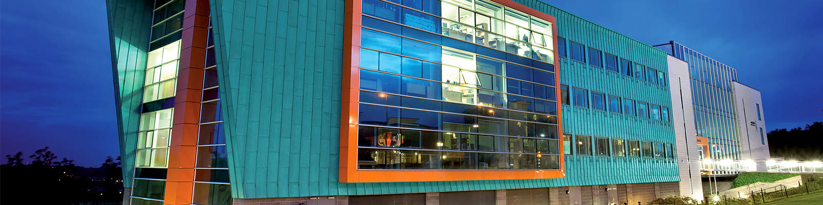Cyber security is a key emerging market opportunity for Lancashire. Two of our leading universities; Lancaster University and University of Central Lancashire offer Cyber Security courses. In 2020, Lancaster University was recognised as one of only eight UK Universities for its commitment to cyber security education, cementing its existing long-established track record of being at the forefront of cyber security research and through the National Cyber Security Centre.

On the back of the successful of cyber security sector, Security Lancaster, a centre of excellence has been established at the University of Lancaster. The centre adds to the areas strength in cyber security and facilitates collaboration with companies from a range of sectors and governments, expanding industry and research capabilities. We also have strengths in the commercial applications of space and there are emerging market opportunities in Space Technology through the development of a Space Technology Cluster.
Figure 6-6: Drone Zone

Future Mobility & Drone Zone
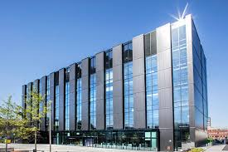
The Future Mobility Zone (FMZ) led by UClan and featuring Preston City Drone Zone will provide a Full-scale technology Demonstrator and Economic Cluster. The FMZ will be a nationally significant demonstrator for mobility services.

The zone will rapidly drive progress in drone use over the next four years, enabling industry and the public sector to fully exploit the opportunities that drones can bring to mobility. Working in conjunction with the Engineering Innovation centre at UClan this proposition builds on the research, engineering and aerospace strengths of the county and will complement our other research assets in Lancashire helping to create a joined up network of hubs accessible to industry.

Figure 6-2: Healthy Productive Communities
Health Innovation Campus (HIC)
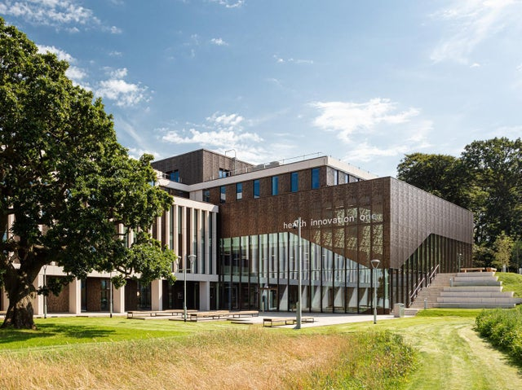
Lancaster University’s £41m Health Innovation Campus opened its doors in 2020 (phase 1) as the first wave of COVID-19 came to an end in summer 2020. It is a physical hub which brings together industry, research partners, health and care providers, the voluntary sector and local authorities – creating an innovation ecosystem.

The Campus has the potential to be a part of the solution to our area’s health problems, with its core aim being to develop substantiable solutions for some of the most important health and care challenges faced by society. It will also address health and social inequalities which impact on wellness and support the SME business community to innovate, with fully funded opportunities for SME businesses in Lancashire to grow and innovate in health as part of the Campus programme of activity.

Innovation Diffusion and Adoption

Rationale & objectives
      - We are home to a diverse range of innovative companies – this includes large multi nationals and more agile SMEs and start-ups. However, in line with the wider UK, we also have a long tail of less innovative and less productive companies. We must broaden our innovation capacity and capability and create a more pervasive culture of innovation across our business base.
      - Although there are numerous excellent examples of innovation across our SME base, on average, business R&D expenditure per head across Lancashire is comparatively smaller than most regions in the England and only 21% of businesses are deemed ‘knowledge intensive’, compared to 26% across the North West and 28% for the UK as a whole.
      - Diffusing innovation more widely and enabling local businesses to adopt new technologies, processes and mindsets will increase the resilience, productivity and competitiveness of individual businesses and our economy as whole. Key to this is leadership and management support to develop new business models that guide suitable technology adoption that have bottom line and sustained impact. Lancashire needs to build on its strengths delivering Be the Business, Made Smarter and Productivity through People which have demonstrated the importance of assets such Lancaster University Management School (LUMS) working alongside the Growth Hubs and UCLan, Edge Hill and AMRC(NW) aligning their productivity offerings.
      - The Universities have offered a range of innovation support programmes through ESIF and other initiatives and the engagement of students, graduates and post-graduates at significant scale has supported thousands of SMEs over a number of years, driving necessary absorptive capacity into businesses and supporting talent retention in the County. As ESIF draws to a close it will be vital that the assets and capabilities of providers of innovation support are harnessed in the next stage to lever and partner with Government initiatives to ensure Innovation Diffusion and Adoption.
      - In this way we will be better placed to anticipate and respond to future economic shocks and ongoing economic restructuring. We will also be better placed to take advantage of technological advancement and changing global markets.
Figure 6-7: Diffusion & Adoption Objectives
Priority area | Objective
Priority 1: Create a culture of innovation across local business leaders | Raise awareness of the opportunities for innovating and the benefits it can bring
 | Enhance innovation leadership and management skills to enable companies to plan profitable technology adoption
 | Promote collaboration and knowledge sharing amongst the business community, such as through peer-to-peer networks and mentoring
Priority 2: Enable businesses to take advantage of new technologies and processes | Unlock R&D and innovation investment by supporting businesses to access finance and expertise
 | Enable business R&D and innovation through increased collaboration between the business community and universities, such as through a range of Knowledge Transfer partnerships.
 | Support businesses to digitise and automate their processes to increase efficiency.

Assets & opportunities
      - Innovation stimulus, challenges, advice and support programmes are ongoing across Lancashire’s public and private sectors that support wider increases in innovation activity among the Lancashire business base and wider adoption of new technologies to drive productivity and competitiveness. Evolved through ESIF programmes in the main, the aim going forward is to streamline projects into fewer, bigger and more connected offerings driven by clusters of businesses.
      - The existing programmes include support in key areas or stages of innovation as follows:
- Advice to assess product ideas and provide expertise eg Innovation Clinic and UNITE Plus
- Access to digital tech awareness and adoption eg DigitME2, CyberFoundry or IN4.0
- In-depth support for tech adoption and leadership in manufacturing eg Made Smarter
- Workshops for business modelling and productivity eg Productivity Innovation Centre
- Specialist support for R&D (decarbonisation, new materials etc) eg Eco-I NW, MaCaW, GISMO
- Support for specialist sectors (health, chemicals, space etc) eg Health Matters, HIC, NextGenChem, ESA
- Access to investment and growth capital eg UCLan’s Investment Readiness, Campus Capital, NxNW
      - We have a network of innovation centres and accelerators across Lancashire offering high quality, specialist floorspace and business support services to innovative start-ups and SME from across a range of sectors. These Centre’s provide access to technologies, research expertise and laboratories that would otherwise be out of the reach of our SME business base. Most are based within universities or specialist FE colleges and some are situated within towns as incubators such as Fraser House in Lancaster and Strawberry Fields in Chorley.
      - We must also recognise and build on emerging innovation strengths, evidenced by IPO data show strong intellectual property advances in areas such as Civil Engineering, Mechanical Elements, Medical and Computer Technology, and Thermal Processes.
Figure 6-9: Low Carbon Lancashire Eco-Innovation Hub

Low Carbon Lancashire Eco-Innovation Hub
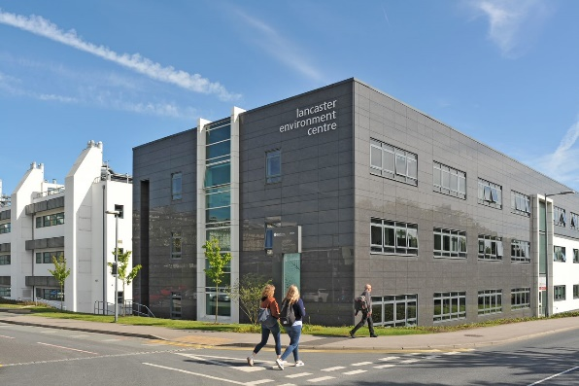
Energy costs are rising, air pollution causes 40,000 deaths per annum, flooding costs an estimated £5bn. Eco-Innovation is both good for business, with a market potential of $6.4tr worldwide, and good for the environment. Lancaster University’s Centre for Global Eco-Innovation is a nationally award-winning initiative which undertakes research and development with business.
Low Carbon Lancashire Eco-Innovation Hub is a R&D programme for SMEs delivering innovation for a better environment, such as the development of a new low carbon technology, efficiency saving or waste reduction process, with a potential return of investment over £100,000. Funded by ERDF, the Lancaster University Management School and Centre for Global Eco-Innovation led programme offers a variety of support, access to people, resources and R&D facilities to develop innovative products, processes and services, including:
- Access to expertise available from environmental sciences, chemistry, quantum technology, mechanical engineering, chemical engineering, electronic and electrical engineering, natural sciences, physics, psychology, marketing and management.
- Recruitment of dedicated PhD and Masters research projects, fully funded dissertation/placement projects undertaken by undergraduates in appropriate disciplines, and fully funded internship projects delivered by current student or recent graduate.
- Workshops and innovation challenges – Peer to peer business workshops for directors and managers addressing how to accelerate, manage and succeed with innovation through the Lancaster University Management School’s Low Carbon Innovation Forum.
- Facilities use includes testing and developing products and materials at workshops and laboratories at Lancaster University
Figure 6-10: Innovation Clinic

Innovation Clinic
The Innovation Clinic is delivered by UCLan and is part-funded by UCLan and the European Regional Development Fund, for SMEs looking to grow their business by launching a new product. The Clinic team of industry and academic experts, and state-of-the-art facilities and technology, provide fully funded advice and support on product feasibility, design, development and testing and product launch strategies, such as:
- Independent idea evaluation & feasibility analysis
- Market research, demand and competitor analysis
- Advice on IP and freedom to operate
- Innovation strategy
- Product design support
- Prototype development
- Product testing
- Brand development
- Materials, supply chain and manufacturing advice
- Commercialisation
The Innovation Clinic to date has helped almost 220 businesses to develop new products.

Distributed Ledger Technology (DLT), Artificial Intelligence (AI), Extended Reality (XR) and Quantum technologies
https://www.boostbusinesslancashire.co.uk/support/health-innovation-campus/

